А 5/1
Код:
# from bit import BitArray
import re
for_big_text = "АБВГДЕёЖЗИЙКЛМНОПРСТУФХЦЧШЩЪЫЬЭЮЯ".lower() + "АБВГДЕЁЖЗИЙКЛМНОПРСТУФХЦЧШЩЪЫЬЭЮЯ" + " !\"#$%-'()*+,—–./:;<=>?@[\]^_`{|}"

mode = int(input("выберите режим (1 - карточка, 2 - большой текст): "))

if mode == 1:
text = input("Введите текст: ").upper()
else:
text = input("Введите текст: ")
text_reg = ''
for i in text:
c = str(bin(for_big_text.find(i)+1))[2:]
while len(c) != 8: c = '0' + c
text_reg += c
key = [1] * 64

x = [0, 0, 0, 0, 0, 0, 0, 0, 0, 0, 0, 0, 0, 0, 0, 0, 0, 0, 0]
y = [0, 0, 0, 0, 0, 0, 0, 0, 0, 0, 0, 0, 0, 0, 0, 0, 0, 0, 0, 0, 0, 0]
z = [0, 0, 0, 0, 0, 0, 0, 0, 0, 0, 0, 0, 0, 0, 0, 0, 0, 0, 0, 0, 0, 0, 0]

gamma = ''

def F(x, y, z):
return (x & y) or (x & z) or (y & z)

for i in range(64):
x.append(x[1] ^ x[2] ^ x[5] ^ x.pop(0) ^ key[i])
y.append(y[1] ^ y.pop(0) ^ key[i])
z.append(z[1] ^ z[2] ^ z[15] ^ z.pop(0) ^ key[i])
# print(*x)
# print(*y)
# print(*z)
# print("------------------------------------------")

for i in range(100):
f = F(x[10], y[11], z[12])
if x[10] == f:
x.append(x[1] ^ x[2] ^ x[5] ^ x.pop(0))
if y[11] == f:
y.append(y[1] ^ y.pop(0))
if z[12] == f:
z.append(z[1] ^ z[2] ^ z[15] ^ z.pop(0))

for i in range(114):
gamma += str(x[0] ^ y[0] ^ z[0])
f = F(x[10], y[11], z[12])
if x[10] == f:
x.append(x[1] ^ x[2] ^ x[5] ^ x.pop(0))
if y[11] == f:
y.append(y[1] ^ y.pop(0))
if z[12] == f:
z.append(z[1] ^ z[2] ^ z[15] ^ z.pop(0))

gamma = gamma*500
text_enc = ''
for i in range(len(text_reg)):
text_enc += str(int(text_reg[i]) ^ int(gamma[i]))
text_dec = ''
text_dec_res = ''
for i in range(len(text_enc)):
text_dec += str(int(text_enc[i]) ^ int(gamma[i]))
text_dec_sub = re.findall(".{8}", text_dec)
# print(text_dec_sub)
for i in text_dec_sub:
text_dec_res += for_big_text[int(i, 2)-1]
print(text_enc)
print(text_dec_res)

Пример работы:
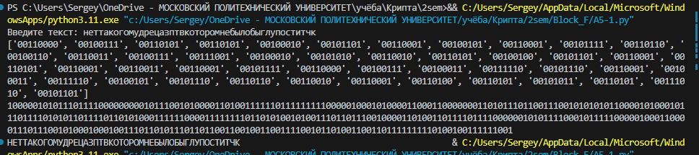
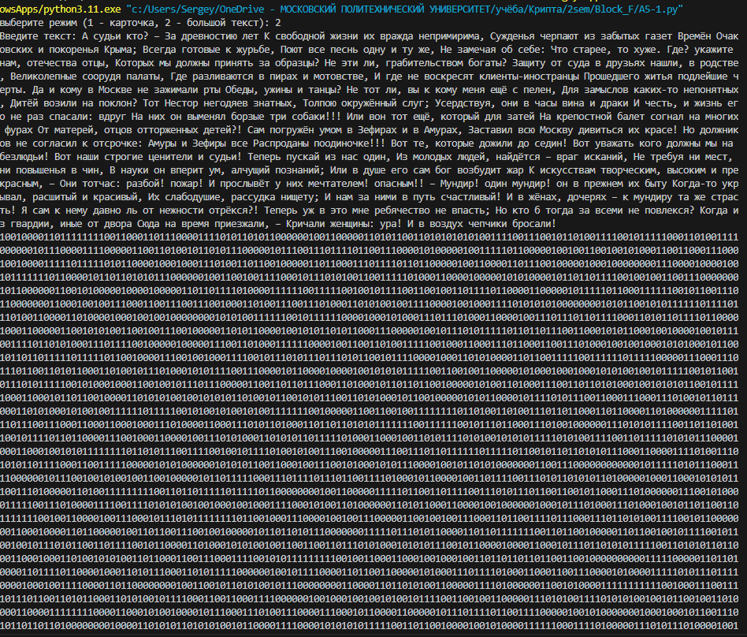
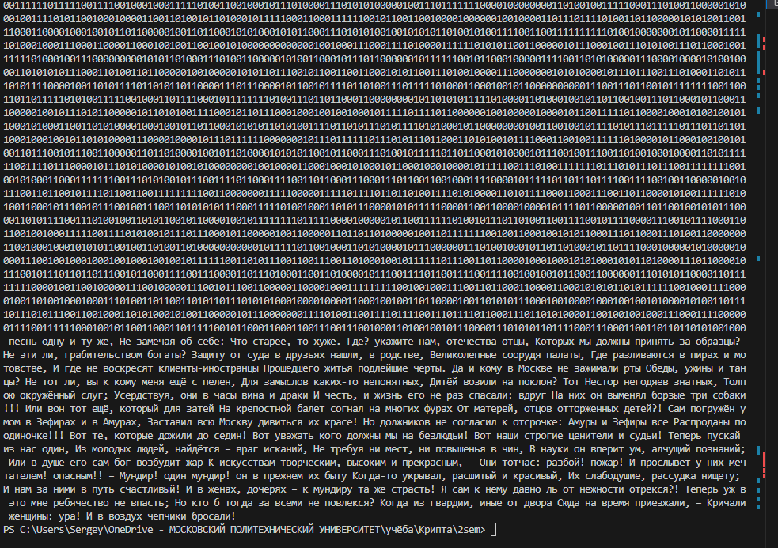
Ручная проверка:
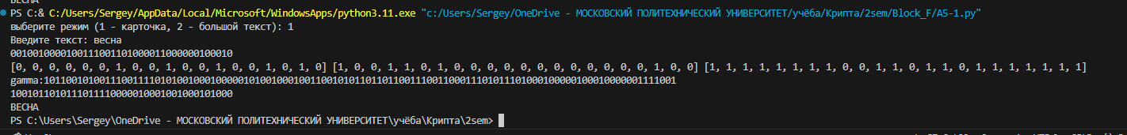
A5/2
Код:
# from bit import BitArray
import re
for_big_text = "АБВГДЕёЖЗИЙКЛМНОПРСТУФХЦЧШЩЪЫЬЭЮЯ".lower() + "АБВГДЕЁЖЗИЙКЛМНОПРСТУФХЦЧШЩЪЫЬЭЮЯ" + " !\"#$%-'()*+,—–./:;<=>?@[\]^_`{|}"

mode = int(input("выберите режим (1 - карточка, 2 - большой текст): "))

if mode == 1:
text = input("Введите текст: ").upper()
else:
text = input("Введите текст: ")
text_reg = ''
for i in text:
c = str(bin(for_big_text.find(i)+1))[2:]
while len(c) != 8: c = '0' + c
text_reg += c
key = [1] * 64
print(text_reg)

x = [0, 0, 0, 0, 0, 0, 0, 0, 0, 0, 0, 0, 0, 0, 0, 0, 0, 0, 0]
y = [0, 0, 0, 0, 0, 0, 0, 0, 0, 0, 0, 0, 0, 0, 0, 0, 0, 0, 0, 0, 0, 0]
z = [0, 0, 0, 0, 0, 0, 0, 0, 0, 0, 0, 0, 0, 0, 0, 0, 0, 0, 0, 0, 0, 0, 0]
r4 = [0, 0, 0, 0, 0, 0, 0, 0, 0, 0, 0, 0, 0, 0, 0, 0, 0]
gamma = ''

def F(x, y, z):
return (x & y) or (x & z) or (y & z)

for i in range(64):
x.append(x[1] ^ x[2] ^ x[5] ^ x.pop(0) ^ key[i])
y.append(y[1] ^ y.pop(0) ^ key[i])
z.append(z[1] ^ z[2] ^ z[15] ^ z.pop(0) ^ key[i])
r4.append(r4[5] ^ key[i] ^ r4.pop(0))
# print(*x)
# print(*y)
# print(*z)
# print("------------------------------------------")
r4[6], r4[9], r4[13] = 0, 0, 0

for i in range(99):
if r4[6]:
x.append(x[1] ^ x[2] ^ x[5] ^ x.pop(0))
if r4[9]:
y.append(y[1] ^ y.pop(0))
if r4[13]:
z.append(z[1] ^ z[2] ^ z[15] ^ z.pop(0))
r4.append(r4[5] ^ r4.pop(0))

for i in range(114):
f1 = x[3] ^ x[4] ^ x[6]
f2 = y[6] ^ y[9] ^ y[13]
f3 = z[4] ^ z[6] ^ z[9]
gamma += str(x[0] ^ y[0] ^ z[0] ^ f1 ^ f2 ^ f3)
if r4[6]:
x.append(x[1] ^ x[2] ^ x[5] ^ x.pop(0))
if r4[9]:
y.append(y[1] ^ y.pop(0))
if r4[13]:
z.append(z[1] ^ z[2] ^ z[15] ^ z.pop(0))
r4.append(r4[5] ^ r4.pop(0))
print(x, y, z)
print("gamma:" + gamma)

gamma = gamma*500
text_enc = ''
for i in range(len(text_reg)):
text_enc += str(int(text_reg[i]) ^ int(gamma[i]))
text_dec = ''
text_dec_res = ''
for i in range(len(text_enc)):
text_dec += str(int(text_enc[i]) ^ int(gamma[i]))
text_dec_sub = re.findall(".{8}", text_dec)
# print(text_dec_sub)
for i in text_dec_sub:
text_dec_res += for_big_text[int(i, 2)-1]
print(text_enc)
print(text_dec_res)

Пример работы:
